Low Level Design (CHANGE PAssword module)

Project Code | Team1
Project Name | E-Commerce(Online Shopping)

Prepared/Modified by | Role | Date of Preparation
Nikeeta Menon | Software Engineer | 16/12/2013
Reviewed by | Role | Date of Review
Mrunalee Kothari | Software Engineer | 17/12/2013
Approved by | Role | Date of Approval
Uma M. Ponniamman | Training Manager
Circulation List | amit.agarwal@igate.com, mrunalee.kothari@igate.com, keerthi.parthasarathy@igate.com, nidhi.shetty@igate.com, nikeeta.menon@igate.com, shrikant.sutar@igate.com, bhagyashree.vedpathak@igate. | Version Number of the template:1.0
Version Number | 1.3

Table of Contents

1. Description Of The Unit 3
2. References 4
3. Dependencies / Assumptions 5
4. Class Diagrams 6
5. Sequence Diagrams 7
6. Design Components 8
6.1 List Of UI Components 8
6.2 List Of Design Classes 8
7. Re-Usable Routines/Components 9
8. Messages 10
9. Configuration Files 11
10. Crud Matrix Table 12
11. Data Mapping Matrix 13
12. Action Flow Matrix 14
13. Stored Procedures 15
14. Program Specification / Pseudo Code 16
REVISION HISTORY OF THE WORK PRODUCT 17

Description Of The Unit

The Change Password module allows the users of the application which is inclusive of the Customer, Sales Manager, Admin to Change their respective using their valid credentials.

The Username and password entered by the user is first validated from the database on clicking of ChangePassword button, only after which the new password is updated in Database else he is redirected back to the ChangePassword Page with an error message, ‘Invalid username/password’.

References

Reference | Description
Repository reference | https://IGTEBLRSVNTNG.igatecorp.com/svn/oct3_Team1
Class Diagram | /Project Documents/Design Documents/HLD/Class Diagrams
URS | /Project Documents/Requirements/Case Study/Ecommerce-grp1 and grp3.doc
UTP | /Project Documents/Test Plan/UTP/Test Cases/Change Password/ UTP_ChangePasswordModule.xls
DB Design | /Project Documents/Design Documents/HLD/DB Design/E-Commerce_GROUP_DBDESIGN.xls

Dependencies / Assumptions

Dependencies:
This module is dependent on the Login module. The link for change password is provided on the login page. Also, the registered customer only can change the password.

Assumptions:
UserId and password of the user are in the database.

Class Diagrams

Class Diagram

Sequence Diagrams

Sequence Diagram
NA

Design Components

List Of UI Components
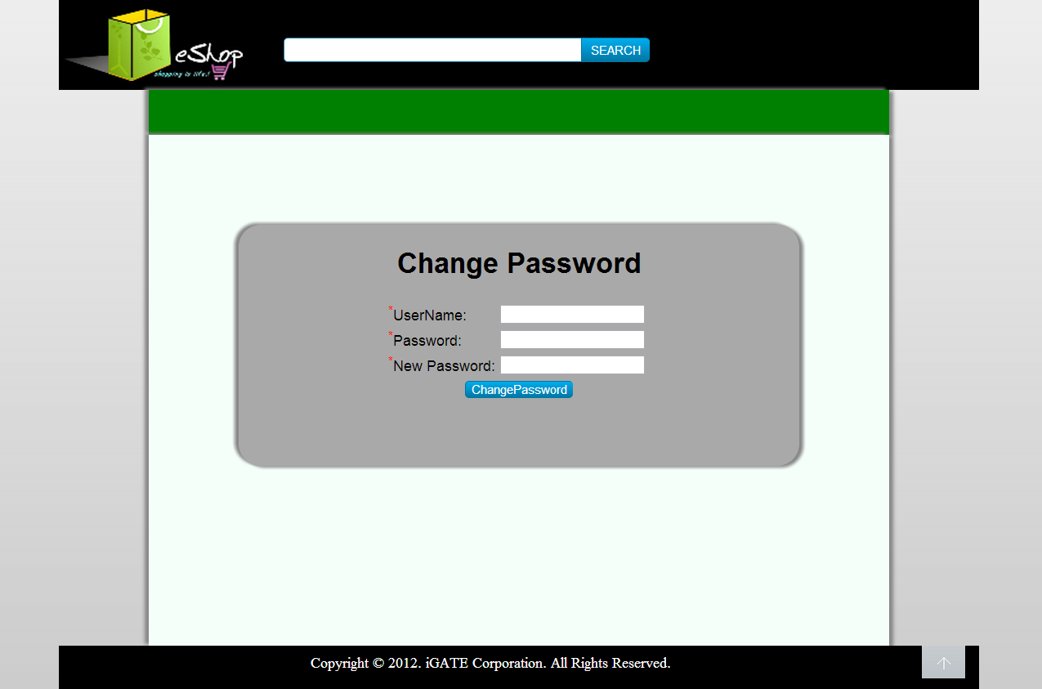

List Of Design Classes

Sr. No. | LLD Name | Class Name | Method Name | Method Description
1 | Change Password Module | User | Appropriate getters and setters methods | Getters retrieve the property values and setters set the property values
2 | Change Password Module | EshopController | (Model model):String  checkLogin(User user ,BindingResult result,HttpServletRequest request):String | Sets the model attribute.  Calls validate(user) of ResetDao class. If it returns Boolean value then it is redirected to Success page else it is redirected to Reset Page with appropriate error message.
3. | Change Password Module | ResetDao | validate():user | Validates userid and password as per the database and returns the result to ResetDao
4. | Change Password Module | EshopController | updateRec():user | Calls updateRec(user) of the ResetDao and returns result to the Controller
5. | Change Password Module | ResetDao | updateRec():user | Updates the new password into database.

Re-Usable Routines/Components

Re-Usable Routines/Components

- CSS files
- Javascript files
- DataAccessException class
- Database properties files
- Logger properties files

Messages

#. | Type | Message Text
M1 | Error | UserName cannot be empty
M2 | Error | Enter a valid username/password
M3 | Error | Password cannot be empty
M4 | Error | NewPassword cannot be empty

Configuration Files

File Name | Path | Description
oracle.properties | /Development/Source | To configure database connection.
Web.xml | /Development/Source | To configure the bean properties.
Dispatcher-servlet.xml | /Development/Source | To configure the request mapping and view resolver.
Eshop_logger.properties | /Development/Source | To configure the logger.
Eshop_error.properties | /Development/Source | To configure error messages.

Crud Matrix Table

# | Table Name | Create | Read | Update | Delete
1 | User | N | Y | Y | N

Data Mapping Matrix

Sr. No. | Screen Label | Field Source | Field Type | Data Type | Max Length | Data Flow | Mandatory
1 | Username | NA | Label | NA | NA | UI | NA
2 | txtUserId | User.User_ID | TextBox | Varchar2 | 10 | UI→D | Yes
3 | Old Password | NA | Label | NA | NA | UI | NA
4 | txtOldPassword | User.Password | TextBox | Varchar2 | 20 | UI→D | Yes
5 | New Password | NA | Label | NA | NA | UI | NA
6 | txtNewPassword | User.Password | TextBox | Varchar2 | 20 | UI→D | Yes
7. | ChangePassword | NA | Button | NA | NA | UI | NA

Legend
D → UI (Database to User Interface)
UI → D (User Interface to Database)
UI (User Interface Only)

Action Flow Matrix

Sr. No. | Action | Description | Process
1 | On click of ChangePassword Button | User Credentials are validated. | UserId and Password is validated from the database. If user is valid, the password is updated in the User_Details_Team1 table and he is navigated to Login page else he is redirected to Change Password page with an appropriate error message displayed.

Stored Procedures

# | Stored Procedure Name  (with Description) | Input/Out Parameters | Type | Size
1. | NA | NA | NA | NA

Program Specification / Pseudo Code

14. 2 <ACTION: LOGIN_CLICK>

Pseudo Code:

- Client Side Scripting:

IF Username isEmpty
Print Error Message M1
IF Password isEmpty
Print Error Message M3
IF Enter new password is empty
Print Error Message M4
IF invalid Username
Print Error Message M2
IF invalid old Password
Print Error Message M2

- Server Side Scripting:
BEGIN
Call prepareChangePassword (Model model) in EshopController class in Service Layer
BEGIN
Call changePassword (@ModelAttribute(“user”)@Valid UserCredentials user, BindingResult result, Model model) in EshopController class in Service Layer.
BEGIN
Call isValidUser(user) in EshopBoImpl in Service Layer.
BEGIN
Call changePassword(UserCredentials user) in EshopBoImpl in Service Layer.
END
Returns Integer value to the EshopController in Service Layer.
END
Return Integer value to EshopController in Service Layer
END
Returns Control to ChangePassword Jsp in Presentation Layer.
END
Returns Control to ChangePassword Jsp in Presentation Layer.

REVISION HISTORY OF THE WORK PRODUCT

# | Date | Version # | Section Changed | Details of changes made | Approved By
1 | 16/12/2013 | 1.0 | LLD prepared | N/A | Uma M Ponniamman
2 | 17/12/2013 | 1.1 | Reusable components,  Pseudo Code,  Messages. | Reusable components added.  More specific control flow specific.  Message text were changed as per the messages of the test cases. | Uma M Ponniamman
3 | 18/12/2013 | 1.2 | Reusable components,  References,  Data Mapping Matrix. | Reusable Components added.  File name with relative path is added in the references section.  The name of text boxes(screen label is changed). | Uma M Ponniamman
4 | 24/12/2013 | 1.3 | Configuration files,UI Components | Paths of the configuration files is updated and UI components(Screen Shots) added. | Uma M Ponniamman

